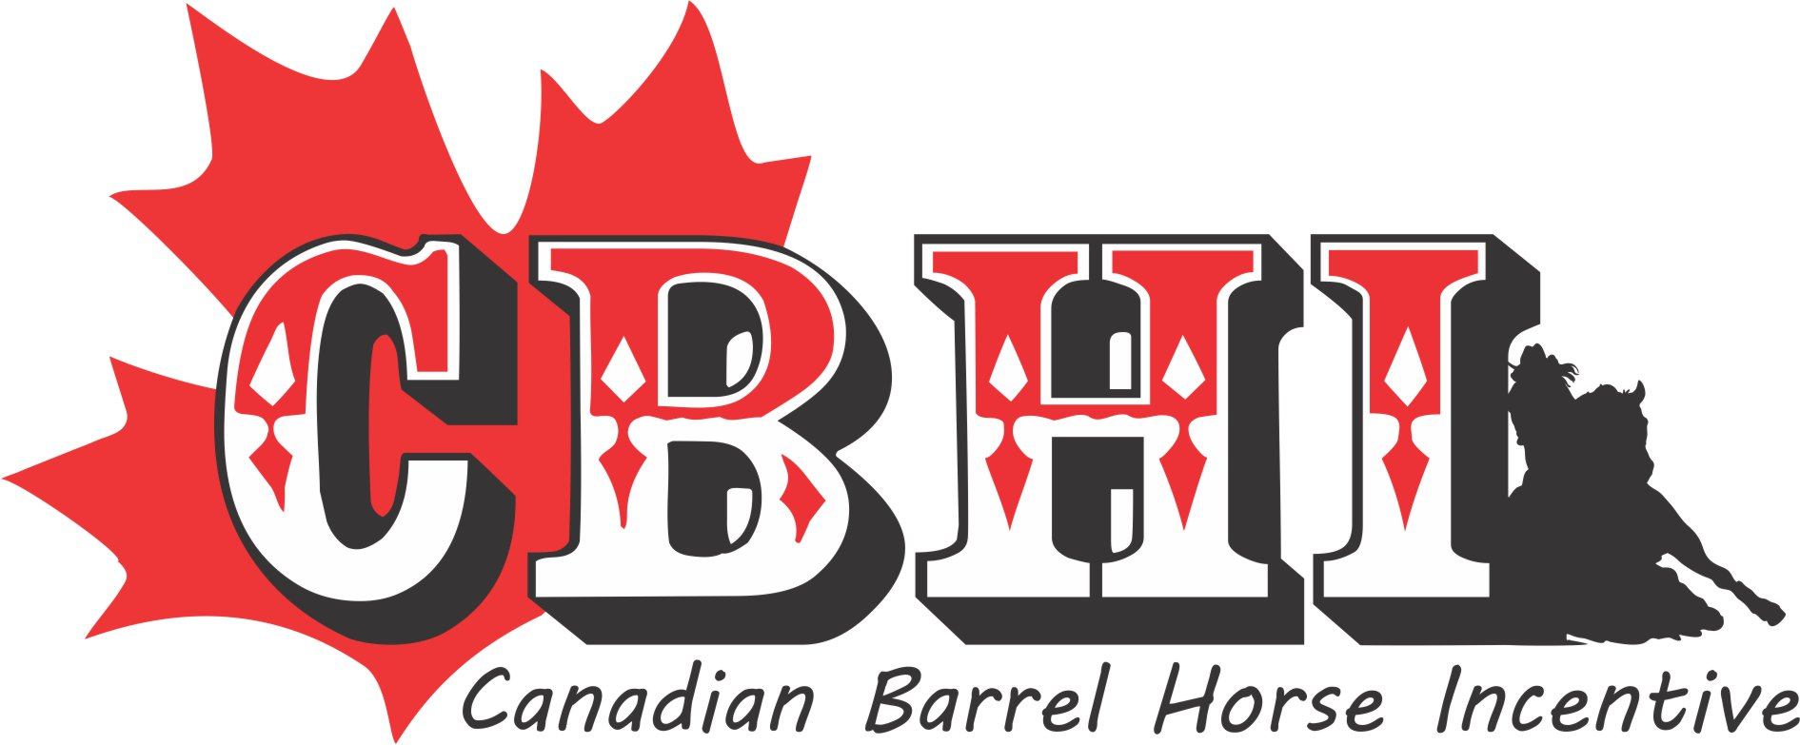
www.canadianbarrelincentive.com
Super Stakes Bidding Form February 1st – 29th, 2024
Contact Kelly Danard ph 780-963-0987 text to 780-887-3601
51314 RRD 22Parkland County, Ab T7Y 2H8 Email info@canadianbarrelincentive.com
$$ Canadian Fund's $$ Min Increment is $25
**No bidding form will be excepted without all information filled out.**
Only complete this form once, you can call or email bids in.

*Payment must be in the office NO LATER than March 15th.

Stallion(s) | Bid Amount | Max Bid  (We will bid on your behalf in $25 increments)

Full Name

Complete Address

City, Province & Postal Code

Email Address

Daytime & Night Time phone #’s

Cell #

User Name
(shows on web site)

Initials
(by initialing you have read and agree to all the rules on the website)

(Please give numbers that we can get a hold of you on closing (Feb 29, 2024) in case someone out bids you at the last minute.)
There is a onetime fee of $75.00 on top of your final bid for the super stakes if you are the winning bidder.

Cheques are payable to CBHI or etransfer to info@canadianbarrelincentive.com

