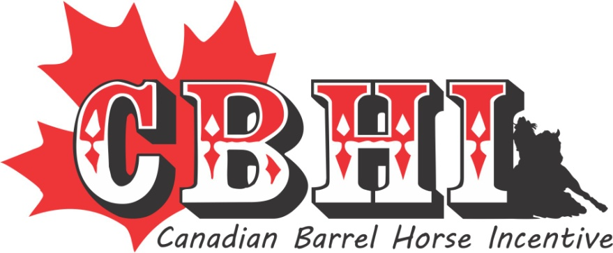

2022 ANNUAL NOMINATION FORM
Deadline for payment is Dec 1st (must be in the office)-Please keep a copy of this form your receipt.
* The Stallion’s advertising poster/flyer can be e-mailed in a Jpeg format*

Name & Registration # of the Stallion {Include a copy of the papers}:

_________________________________________________________________________

Owner(s):_________________________________________________________________

Address:__________________________________________________________________

City/Province:______________________________________________________________

Postal Code:________________ Phone # (s) ____________________________________

E-mail:____________________________________________________________________

Web Site:__________________________________________________________________
Nomination Fees:
Partial- Stallions without offspring of competition age &/or are not competing themselves | $250
Full- Stallions with offspring of competition age &/or are competing themselves. | $500
Deceased- Stallions with no frozen semen. | $250
Worker/Volunteer fee -$25 per stallion | $25 | $25
TOTAL
* Worker/Volunteer fee is to offset help that we have to hire to make our events run smoothly.

Signature:__________________________________________________
(By signing this you confirm that you understand the difference between the 3 payment choices - no refunds)

Email Transfer’s: info@canadianbarrelincentive.com and use cbhientry as the password

Please circle below if this is a new stallion to the program:
1. You wish to be placed on the Super Stakes waiting list or 2. Not interested in the Super Stakes

CANADIAN BARREL HORSE INCENTIVE
51314 RRD 22 Parkland County, Ab T7Y 2H8
For all incentive and nomination information;

Contact: Kelly Danard 780-963-0987 e-mail -info@canadianbarrelincentive.com

