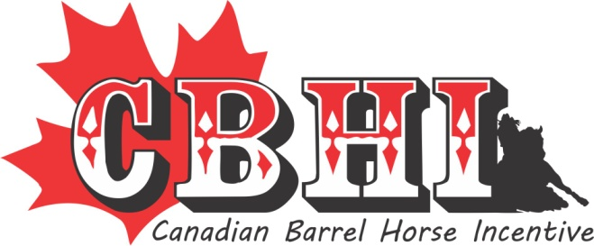
October 6-9, 2022 @ PAECS-Ponoka, Ab
2022 TRADE SHOW BOOTH EXHIBITOR REGISTRATION FORM
INDUSTRY/COMPANY/ORGANIZATION: _____________________________________________________
ADDRESS: _____________________________________________________________________________
CITY/TOWN: _____________________________PROVINCE:_________POSTAL CODE: ________________
TELEPHONE#:____________________________FAX:__________________________________________
CONTACT PERSON: _____________________________________________________________________
EMAIL:_______________________________________________________________________________
EXHIBITOR SPACE (PLEASE CHECK):
1 Booth $300 (8’ long x 12’ wide)
2 Booth $600 (16’ long x 12’ wide)
1 Booth ($150) PLUS PRIZES (Prizes must be in multiples of 2 or 4 and valued at a minimum of $150) = $300
2 Booth ($300) PLUS PRIZES ((Prizes must be in multiples of 2 or 4 and valued at a minimum of $300) = $600
Power $25 for duration of event (must bring your own extension cords)
* Vendors who are providing a service are respectfully asked to donate product only when considering prizes. Due to the vast demographic of our contestants, Gift Certificates are hard to utilize.
*Absolutely no tape/pins used on the walls. If tape is required you can purchase the tape at the office. If you do pin or tape you will be liable for damages.
*Photos of prizes need to be submitted with payment so advertising on social media can be done to increase your exposure and ensure equal value for equal placings.
*Included with paid space is one business card ad in the program (needs to be submitted by Sept 15)
* SERVICE PROVIDERS
Service providers must pay the CBHI a $100 fee and a certificate of Insurance as outlined to the CBHI office in order to have privileges on site. This DOES NOT allow you to work on animals inside the arena or the barn. No advertising inside the arena or barn. Service providers must not interfere with the CBHI event. Must provide your own power.
*Set up Times:
Set up may begin Thursday and must be completed by Friday 1pm.
Pack up may begin Sunday when the competition is completed or when otherwise notified.
If tables are required, Ponoka has some available. They are $50 each and when you return them you receive $40 back.

INSURANCE REQUIREMENTS
The CBHI requires each vendor/service provider that works on animals or people to have a ONE MILLION DOLLAR LIABILITY coverage for the duration of the 2021 CBHI Event.
A certificate of insurance must be submitted prior to Oct 1, 2022 naming the “Canadian Barrel Horse Incentive” as additional insured. The event centre address is – 3611 Hwy 2A, Ponoka AB, T4J 1J8

Payment Information:
Please submit this form by September 15 with payment and ad to the address below and keep a copy of this form for your receipt. Cheques payable to the CBHI OR etransfer to email below and password cbhientry
There will be no refunds.

Vender Signature:______________________________________________________________________________

Date:____________________________________
Canadian Barrel Horse Incentive
51314 RRD22Parkland County, Alberta T7Y 2H8
780-963-0987
info@canadianbarrelincentive.com

