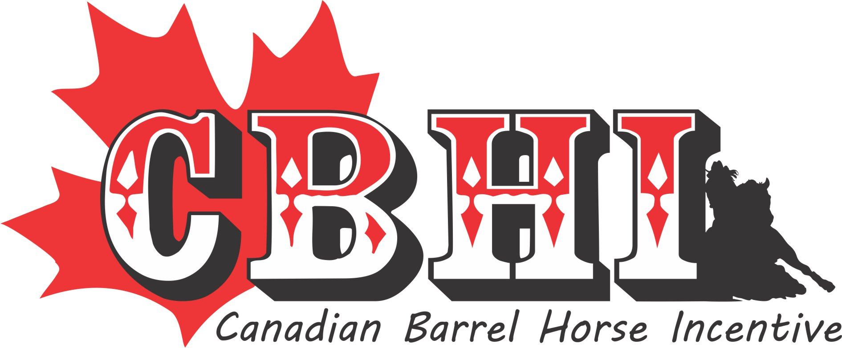
www.canadianbarrelincentive.com
Super Stakes Bidding Form February 1st – 28th , 2018
Contact Kelly Danard ph 780-963-0987 ~ fax 780-466-3091
51314 RRD 22Parkland County, Ab T7Y 2H8 Email info@canadianbarrelincentive.com
$$ Canadian Fund's $$ Min Increment is $25
**No bidding form will be excepted without all information filled out.**
No New Bidders will be accepted after 10am on February 28th, 2018
*The farm location and stud fee are believed to be accurate although the CBHI will not assume any responsibility for errors. All stallion services are sold as per the stallion farm’s rules. It is the bidder’s responsibility to research the specific charges (ex.GST) and conditions with respect to that particular stallion. Shipped cooled semen, mare care, chute /farm fees and veterinarian /farrier etc. services are not included. (it may be recommended to research the contract prior to bidding)
*All successful bids are final and all participants accept the rules and regulations before submitting their bid.
*Refunds will only apply in the event of a stallion’s death or inability to breed (as evidenced by a veterinary certificate) (not by gelding).
*The purchasing party will not hold the CBHI or any other entity associated directly to the CBHI and the individuals working in conjunction with it, responsible for any errors and/or liabilities.
*Minimum bid is ½ of the stallion’s current fee or unless noted. In the event of a tie, all parties will be contacted and given the opportunity to bid at a higher figure.
*You only need to fill this form once. After submitting this form you can call or email bids.
*If you are a winning bidder and we do not receive payment in the office by March 15, 2018 you will be banned from ALL CBHI events.
*Please see website for all the rules.
*This auction does NOT run like eBay, whoever you out bid still gets a chance to out bid you.
*Payment must be in the office NO LATER than March 15th.
Stallion | Bid Amount | Max Bid  (We will bid on your behalf in $25 increments)

Full Name

Complete Address

City, Province & Postal Code

Email Address

Daytime & Night Time phone #’s

Cell #

User Name
(shows on web site)

Initials
(by initialing you have read and agree to all the rules)

(Please give numbers that we can get a hold of you on closing (Feb 28, 2018) in case someone out bids you at the last minute.)
There is a onetime fee of $75.00 on top of your final bid for the super stakes if you are the winning bidder.

Cheques are payable to CBHI or etransfer to info@canadianbarrelincentive.com password:cbhiss

