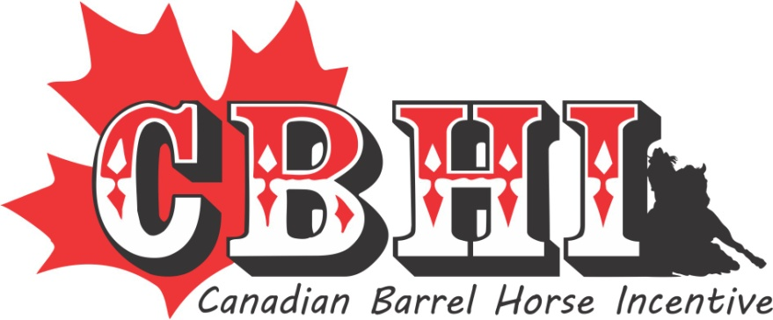

2017 ANNUAL NOMINATION FORM
Deadline for payment is Dec 1st
Name & Registration # of the Stallion { Include a copy of the papers }:

_________________________________________________________________________

Owner(s):_________________________________________________________________

Address:__________________________________________________________________

City/Province:______________________________________________________________

Postal Code:________________ Phone # (s) ____________________________________

E-mail:____________________________________________________________________

Web Site:__________________________________________________________________

Nomination Fee (circle one)
Partial $250.00- Stallions without offspring of competition age &/or are not competing themselves.
Full $500.00- Stallions with offspring of competition age &/or are competing themselves.
Deceased Stallions $250.00- Stallions with no frozen semen.

Signature:__________________________________________________
(By signing this you confirm that you understand the difference between the 3 payment choices - no refunds)

Please circle: If this is a new stallion to the program

1. You wish to be placed on the SS waiting list or 2. Not interested in the SS

* The Stallion’s advertising poster/flyer must be e-mailed in a Jpeg format*

CANADIAN BARREL HORSE INCENTIVE
51314 RRD 22 Parkland County, Ab T7Y 2H8
For all incentive and nomination information;

Contact: Kelly Danard 780-963-0987 e-mail -info@canadianbarrelincentive.com

